Monthly order trends
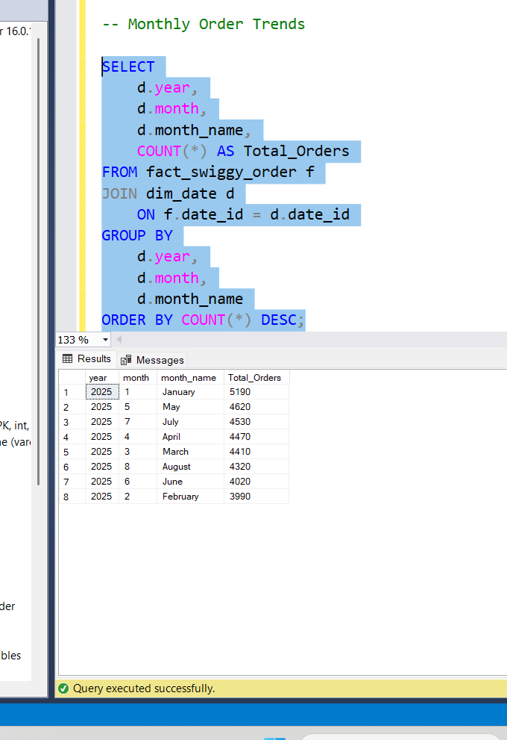
TOTAL REVENUE
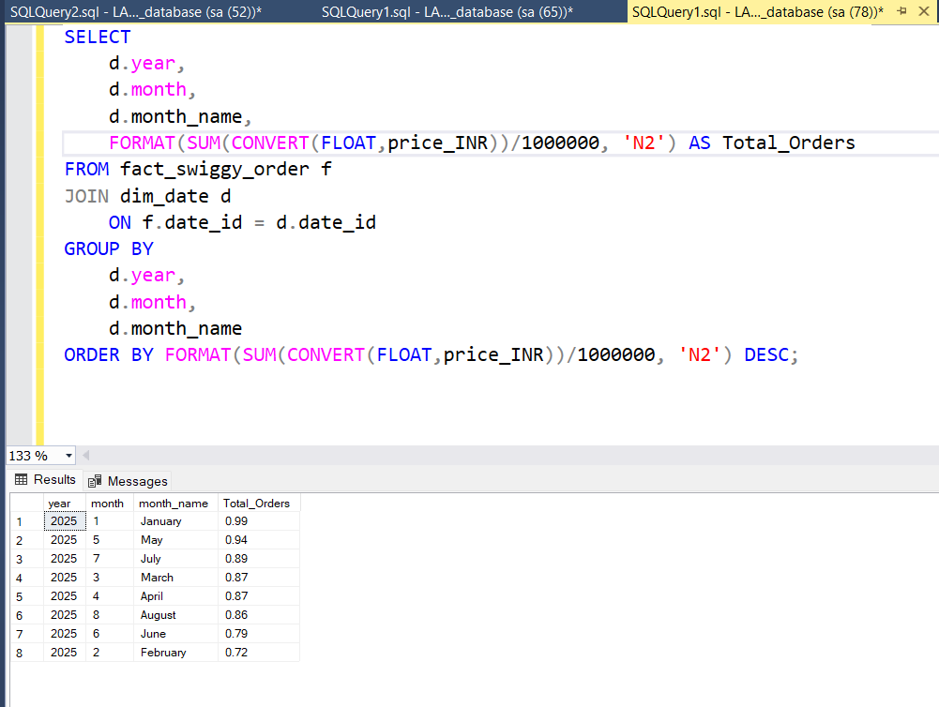

QUATERLY TRENDS
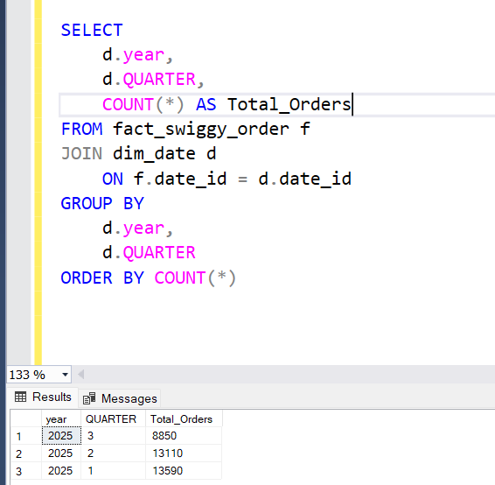

YEARLY TRENDS
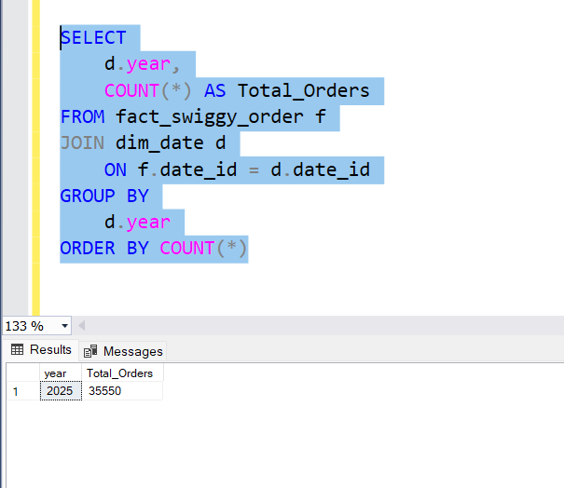
ORDER BY DAY OF WEEK(MON-SUN)
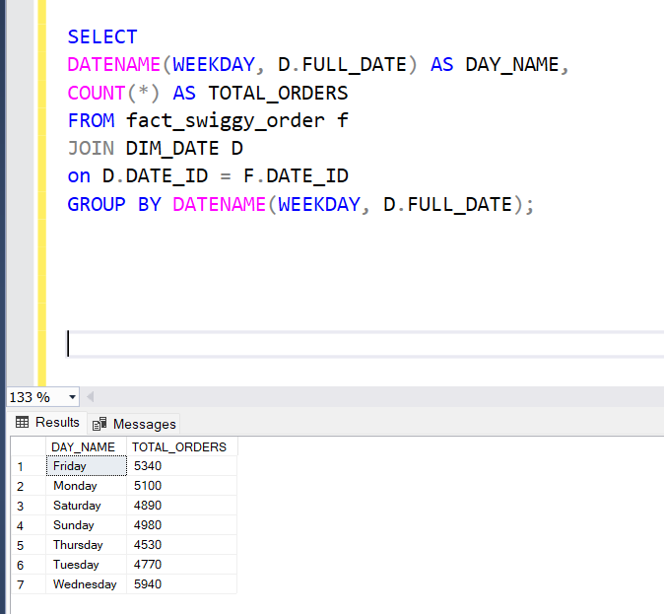

TOP 10 CITIES BY ORDERS
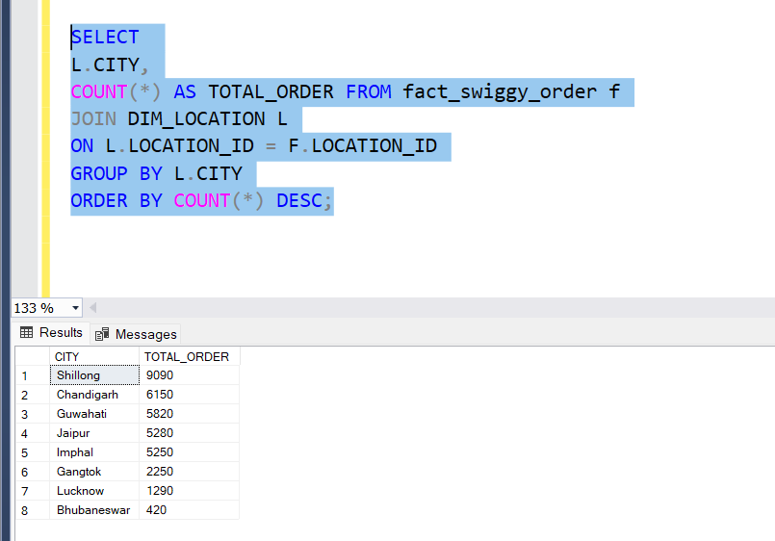

REVENUE CONTRIBUTION BY STATE
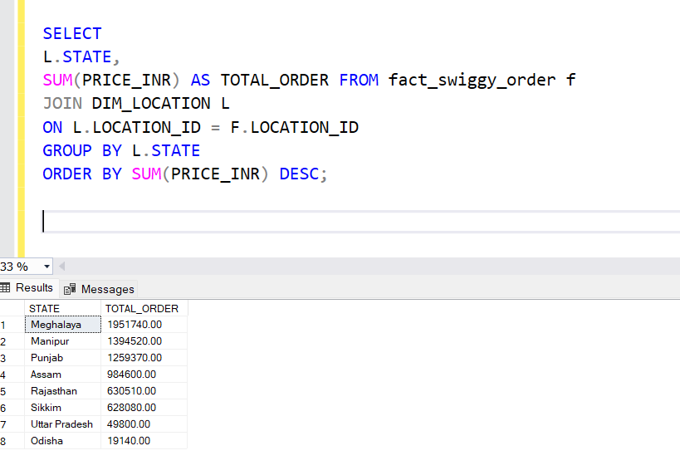
TOP 10 RESTAURANT BY ORDER
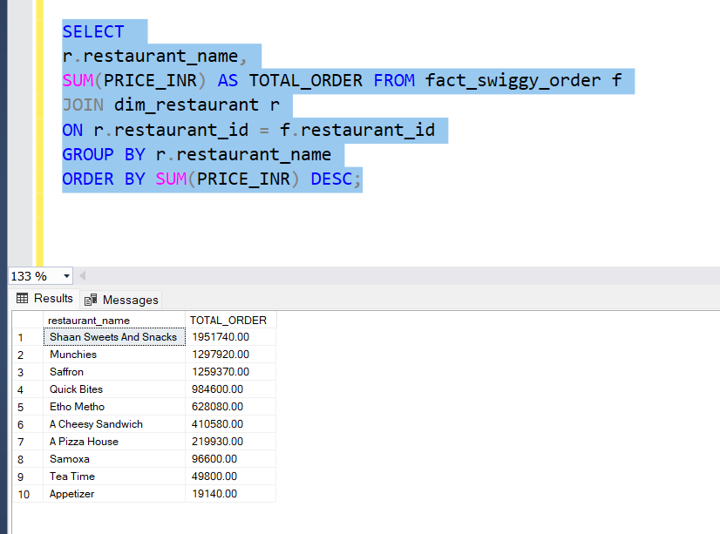

TOP 10 CATEGORY BY ORDER
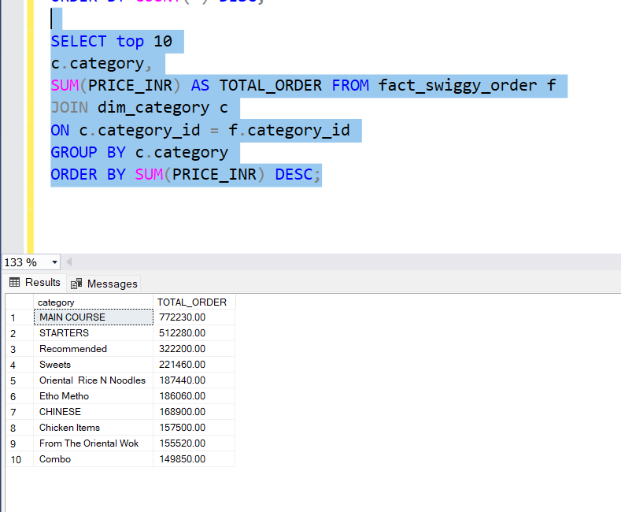
TOP 10 MOST ORDER DISHES
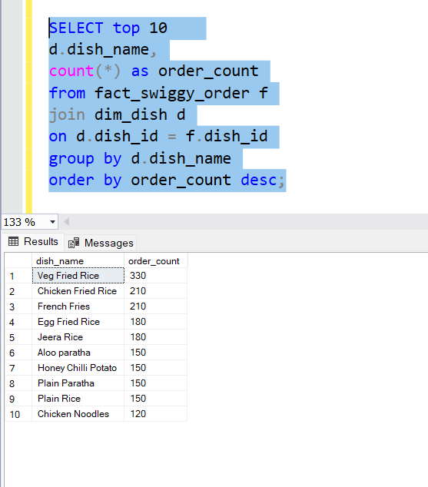
TOTAL ORDER BY PRICE RANGE
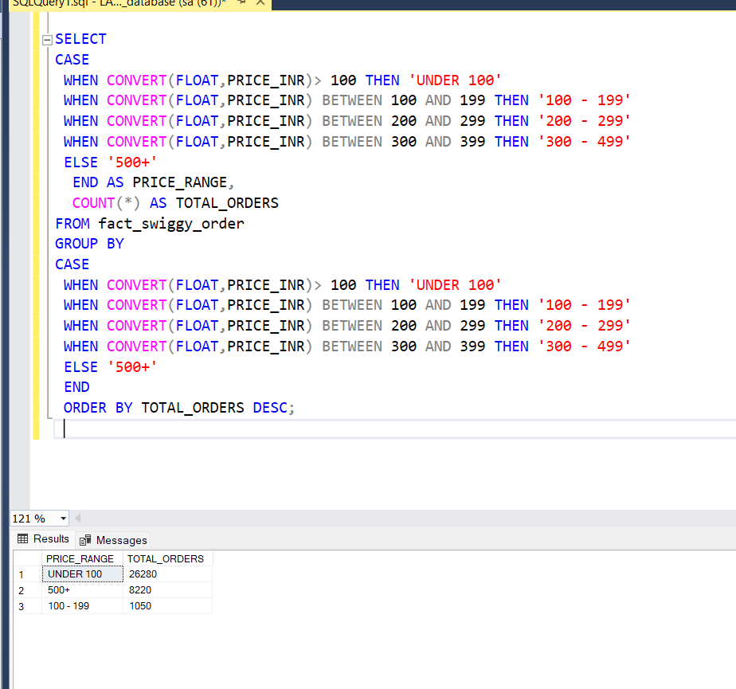
RATING COUNT DISTRIBUTION
